Powering customer success
DAF presents a full suite of product innovations at the IAA 2024
DAF Trucks is setting new standards in fuel efficiency, safety and driver comfort with the launch of a full suite of innovations for its New Generation XD, XF, XG and XG⁺ trucks at the IAA Transportation 2024 in Hanover. In addition, DAF is demonstrating its environmental leadership with a full range of battery electric vehicles for city, regional and long haulage, supported by first class charging stations and energy storage systems.
DAF Trucks has a prominent position in Hall 21 at the IAA Transportation 2024 in Hanover and has created a great display for its complete line-up of products and services that power customer’s success.

- A new Generation XD, XF, XG and XG⁺ sets new standards
  - The power of efficiency
    - PACCAR MX-11 and MX-13 engine optimizations
      - New valve timing
      - Dual drive coolant pump
      - 2-cylinder air compressor
    - Rear axle innovations
      - New pinion design
      - New rear axle ratios
    - Specification fully tuned to fuel efficiency and CO₂ reduction
      - DAF Digital Vision System, Predictive Cruise Control and aerodynamic package as standard
    - 10 year PACCAR Connect as standard
  - The power of safety
    - A full range of Advanced Driver Assistance Systems
  - The power of comfort
    - Even lower noise levels thanks to next level in down speeding
    - New standards in drivability
    - New Truck Navigation App and Connected truck navigation
- A full range of zero emission XB, XD and XF Electric vehicles for city, regional and long haul applications
  - Zero emission ranges up to 500 kilometres
  - LFP (Lithium, Ferro, Phosphate) batteries offer great advantages
    - Cobalt free
    - Outstanding thermal stability for highest safety
    - Excellent durability
  - First class chargers and energy storage systems from PACCAR Power Solutions
- PACCAR Powertrain Display showing the latest and future sustainable driveline options
  - PACCAR MX-13 engine prepared for HVO and B100 FAME biodiesel
  - PACCAR e-Motor
  - PACCAR Fuel cell technology
  - PACCAR MX Hydrogen Engine
  - PACCAR E-Axle

New Generation DAF trucks set new industry-standards

Full suite of innovations to strengthen DAF XD, XF, XG and XG⁺
All New Generation DAF trucks benefit from perfect aerodynamics, highly efficient drivelines and a range of advanced driver assistance systems, resulting in an impressive fuel efficiency improvement of up to 10%. Now, an additional 3% gain can be realized through driveline and aerodynamic enhancements.
The power of efficiency
Optimized driveline efficiency is achieved through new engine valve timing, a dual drive coolant pump and a 2-cylinder clutched air compressor. Turbo and EGR systems have also been updated. New fuel injectors support excellent efficiency, reliability and durability.

Innovations to DAF’s popular SR1344 rear axle program include a new pinion design which offers enhanced strength and durability and also allows the highest PACCAR MX-13 power rating (390 kW/530 hp) to optimally benefit from DAF’s down speeding philosophy. A new shifting strategy of the transmission and the engine optimizations result in 7% lower rpm at cruising speed (950 instead of 1,030), depending on the configuration.

Thanks to their excellent fuel efficiency and low CO₂ emissions, several models of the New Generation DAF meet the Maut Class 3 standards, potentially saving thousands of euros annually in German road tax.

To optimize the efficiency of the New Generation DAF models, the DAF Digital Vision camera system (replacing the conventional mirrors), Predictive Cruise Control and low resistance tires become standard on 4x2 and 6x2 versions* to offer another 6% fuel efficiency gain. For customers who didn’t order these features before, total fuel consumption and CO₂ benefit will be up to 9%. In daily practice, the fuel efficiency gain could be even be larger, as also the aerodynamic package is standard.

All New Generation DAF trucks come with a 10-year PACCAR Connect subscription. This new online fleet management platform provides real-time information on the performance of the entire fleet, individual vehicles as well as drivers to optimize efficiency and returns. The platform also enables efficient over-the-air vehicle updates. A major benefit of PACCAR Connect is the easy integration with existing logistic applications from so called 'third parties', setting a new standard in fleet management systems.

The power of safety
All New Generation DAF trucks are leading the way in safety, thanks to a comprehensive full range of Advanced Driver Assistant Systems (ADAS) which are delivered ex-factory. These include Advanced Emergency Braking System, Drive-off Assist, DAF Side & Turn Assist, Lane Departure Warning and Speed Limit Recognition. And to enhance safety performance, the Event Data Recorder records images and data when the AEBS brake warning is activated, while the new DAF Drowsiness Detection assesses the driver’s state of alertness.

The power of comfort
The driveline updates result in even lower noise levels at cruising conditions. The new shifting strategy of the transmission enhances drivability thanks to an even smoother shifting performance.
The new PACCAR Connect online fleet management platform features Connected Truck Navigation. This allows the home base to send full route planning directly onto the secondary screen in the truck for highest driver comfort.

A full suite of innovations further strengthens the industry leading position of the DAF XD, XF, XG and XG⁺ models, setting new standards in efficiency, safety and driver comfort. Sales will start at the IAA exhibition in Hanover.

DAF demonstrates environmental leadership
At the IAA Transportation 2024, DAF is demonstrating environmental leadership by displaying its full range of state-of-the-art XB, XD and XF Electric vehicles for city, regional and long haul applications. These innovative trucks feature highly efficient drivelines and modular battery packs for ‘zero emission’ ranges up to 500 kilometers on a single charge. All DAF Electric trucks use LFP batteries (Lithium Ferro Phosphate) with a high energy density that are very advantageous in terms of thermal safety, battery lifetime and the number of charging cycles.

In addition to a series of first class electric vehicles, the complete service offering makes DAF the perfect partner in the energy transition. This includes dedicated consulting services, as well as outstanding charging stations from PACCAR Power Solutions, which also offers energy storage systems.
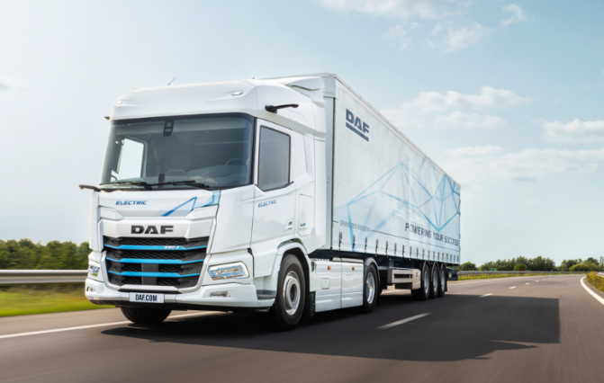

DAF XF Electric truck for zero emission long haulage

On display at the IAA Transportation 2024 is an overview of current and future sustainable driveline solutions. The efficient and reliable PACCAR MX engines are fully prepared to operate on HVO biodiesel, which reduces CO₂ emissions by over 90% ‘well-to-wheel’. Versions that run on B100 Fame biodiesel will become available early next year.

DAF is leading the way in hydrogen technology, as DAF is currently developing a hydrogen combustion engine, which is expected to be ready for market launch in the coming years.
On display at the IAA DAF stand is also an e-Axle, which is under development and illustrates the company’s continuous pursuit of a full suite of highly efficient powertrain solutions.

With a full range of battery electric vehicles backed by a comprehensive dedicated service offering, at the IAA Transportation 2024, PACCAR and DAF are demonstrating their leadership in supporting customers in their energy transition.

‘Ready for the Future’
“The best trucks on the market have become even better”, stated Harald Seidel, DAF Trucks’ president. “As a result of a series of innovations, the New Generation DAF XD, XF, XG and XG⁺ models are setting new standards again in efficiency, safety and driver comfort. Furthermore, we are offering a full range of battery electric vehicles with ranges up to 500 kilometers. In the meantime, we continue to explore and develop alternative, sustainable road transport technologies. Our presence at the IAA Transportation 2024 illustrates that DAF is ready for the future.”

DAF Trucks N.V. — a subsidiary of PACCAR Inc, a global technology company that designs and manufacturers light, medium and heavy-duty trucks. DAF provides a full range of tractor units and vocational trucks, offering the right vehicle for every transport application. DAF is also a leading provider of services, including MultiSupport repair and maintenance contracts, financial services from PACCAR Financial and a first-class parts delivery service from PACCAR Parts.

Hanover, September 16, 2024

Note to editors only

For more information:
DAF Trucks N.V.
Corporate Communication Department
Rutger Kerstiens, +31 40 214 2874
www.daf.com

*) Depending on market and application

